EXERCISE-19

19.Design TM using simulator to perform addition of ‘aa’ and ‘aaa’

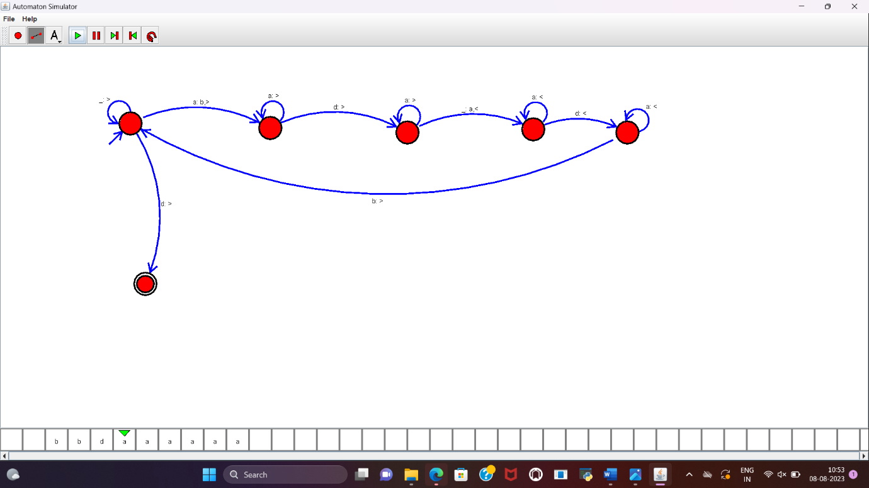

RESULT:

TM to perform addition of “aa” and “aaa” is designed and implemented successfully.